Glossy the Rabbit Book Trail
Executive Summary and Recommendations
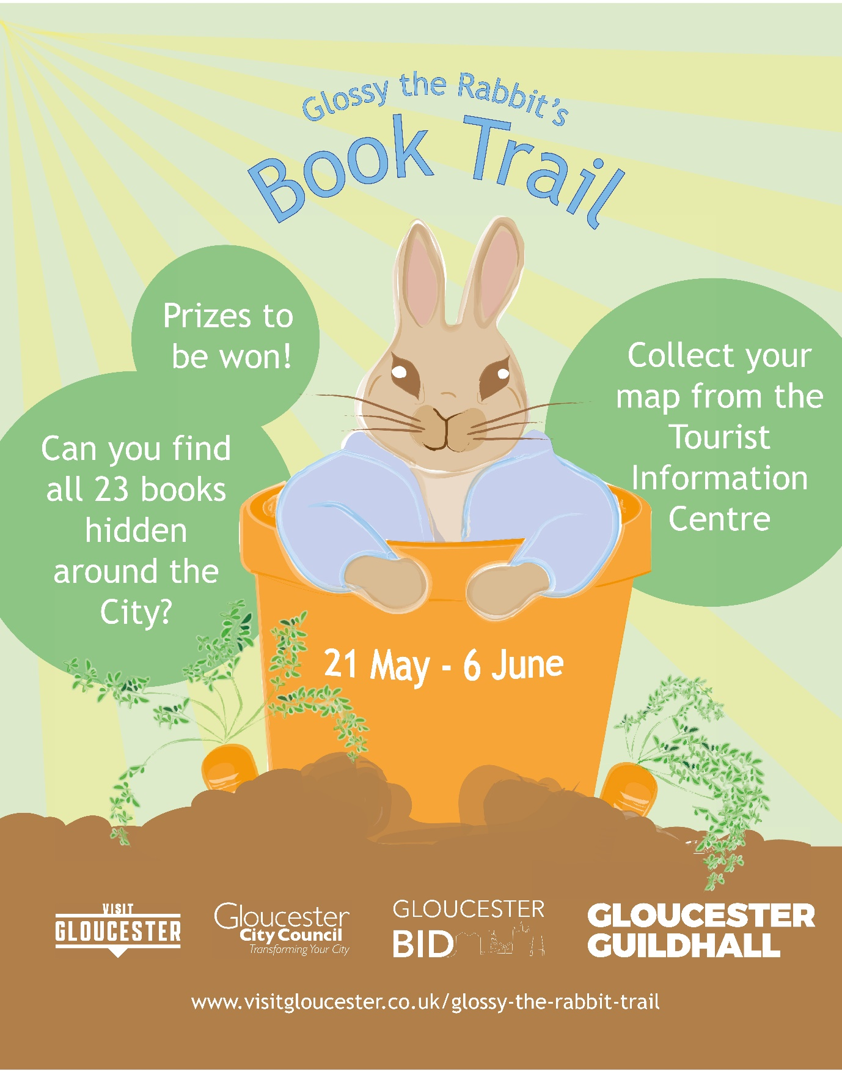

Glossy the Rabbit Book Trail was launched in celebration of Peter Rabbit 2: The Runaway. The trail was designed to encourage people to wander around the City and explore different businesses whilst offering a free activity for families to do over June half term. The trail ran 21 May – 6 June and involved finding different Beatrix Potter books hidden in shop windows (to ensure social distancing can be in place and to make the trail accessible at all times). There were prizes to be won in collaboration with Gloucester BID and Gloucester Guildhall which incentivised exploring and to increase the brand awareness of both brands.
Objectives of the Campaign
The campaign’s objectives were as follows:
- To increase footfall in the City.
- To encourage visitors to explore the City with a focus on the City centre and Docks.
- To promote Gloucester as a location for families.
- To increase the brand awareness of Gloucester BID and Gloucester Guildhall.
Audience
The Book Trail was targeted at Trips and Treats with a focus on Women (as the main decision makers and planners of this type of event). While this group may not view arts and culture as a passion, they are reasonably culturally active, despite being particularly busy with a wide range of leisure interests. This group are led by their children’s interests and strongly influenced by friends and family.
The key geographies for the campaign are Gloucester City Centre and surrounding areas.

The Marketing Mix
The campaign involved a variety of different marketing channels including:
Social Media Advertising
Facebook advertising using the following messages and targeting:
In Gloucestershire
- Have you found all of Glossy's books? Join in the trail to be in with a chance of winning a £50 Gloucester Gift Card and tickets to watch Peter Rabbit 2 at Gloucester Guildhall!
- 5 days to go! Join in the trail to be in with a chance of winning a £50 Gloucester Gift Card and tickets to watch Peter Rabbit 2 at Gloucester Guildhall!
Press and PR
The press release was issued a few weeks before the start date and issues through corporate comms.

Results
Participant Figures
Distributing 600 work sheets to the venues and having 200 remaining we estimate that over 400 people took part in the trail. From this we received 24 online entries to the competition and 35 physicals.

Web Statistics
The campaign looked to encourage visitors to explore the City with a focus on the City centre and Docks, this was tracked through Google Analytics. Page views of the trail page were 1328 over the duration of the event. The website also had a significant 89.90% increase in users (15,790), compared with half term in 2019 (8,315).
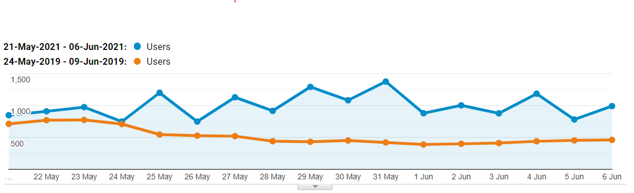
Organic Social Media
We boosted a Facebook post to encourage people to participate in our #GlossyBook Trail competition. This reached 26,659 people and received 332 post engagements.
Our top Instagram post promoting the trail reached 621 accounts and 651 impressions.
Press and PR
- The trail was picked up by local lifestyle magazine So Glos- mentioned in their Gloucestershire half term guide - https://www.soglos.com/children-family/38551/Gloucestershire-May-half-term-guide

Recommendations
- Businesses reported that they saw lots of families participating in the trail and an increase of footfall, however, as the trail only ran over 2 weeks a longer run time for example a trail during the Summer Holidays would increase exposure for businesses and increase opportunity for participation including locals and tourists.
- As over 400 participants took part but under 100 of these entered the competition it is clear that the participants motives were taking part for the entertainment rather than the prizes. Therefore, we will look to include smaller participation prizes in future activities with opportunity for sponsorship for a more widespread approach.
- Participants said that the trail was too long for younger children with some families taking part across 3 days. It is understood that a shorter trail would be more attractive to participants. In order to still be business inclusive we will need to increase the amount of activities we organise like this rather than increase the length of activities.

